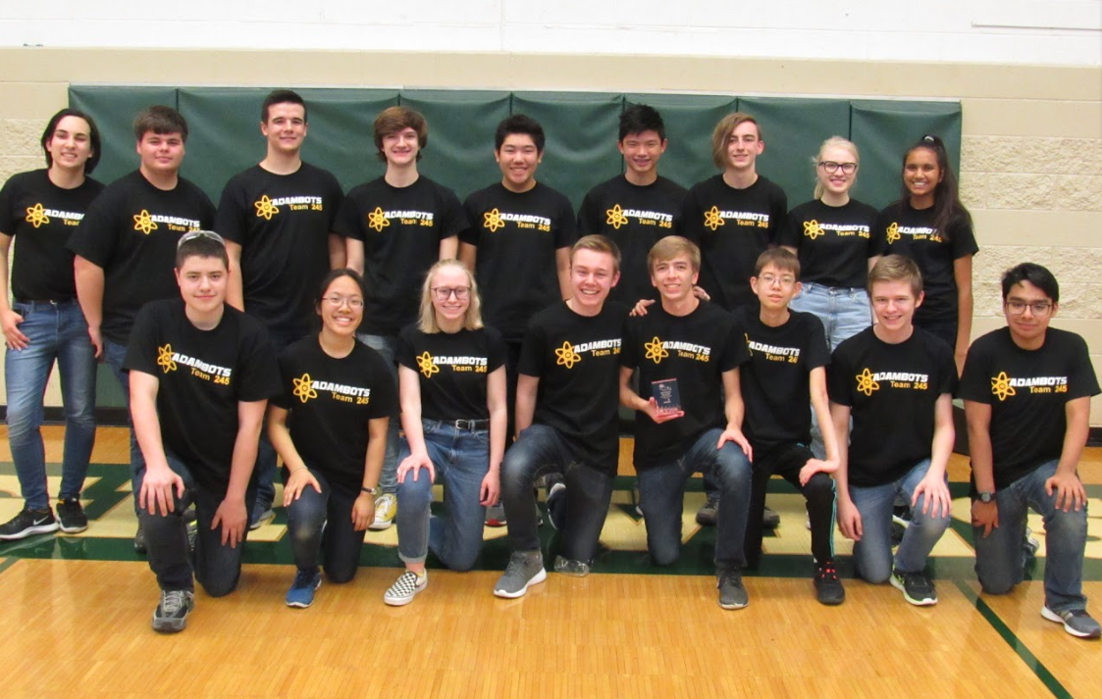

The AdamBots Team 245 from Rochester Adams High School graciously submit our entry for the 2018 OCCRA Foundation Award. Due to our consistent dedication to expanding STEM education opportunities in our community, we request consideration for this prestigious award.

Team History With OCCRA

The AdamBots have competed in OCCRA every year since 2000, the league’s first year. Over the past 18 years, we’ve grown in size, experience, and impact. In the past, OCCRA was our new students’ introduction to robotics, but now, our team views OCCRA as an opportunity for veteran students to develop leadership and technical skills. Our students’ and mentors’ hard work and dedication has led us to five OCCRA championships and five Foundation Awards. Yet, we refuse to slow down. Our OCCRA team has nearly doubled in size since last season, showing our passion for the league. 2018 is proving to be our strongest year in terms of both student development and community involvement!

Growing Students

Our OCCRA team consists of 25 students and 5 mentors, Mr. Hildebrandt, Mr. Cesiel, Mr. Savage, Mr. Sochanski, and Mrs. Alspach with a combined 50 years of robotics mentoring experience. They guide us in tool use, safety, and quality management.

For any new students on the AdamBots, their first experience of the team involves introductions to all aspects of the team. They attend workshops to learn about tools, safety, CAD, programming, technical visual arts, and career skills. New students also get paired with older students in our Buddy System which allows experienced students to help rookies keep up with meetings, workshops, and competitions.

New to this year, the AdamBots are also implementing a certification system for proficiency in various skills. We are defining our subteams in terms of the skills students ought to acquire during their time on the team. Then, according to a leader and mentor evaluation, official certificates will be distributed to students for demonstrated proficiency or excellence in their field. The purpose is to provide students with a goal for which to strive along with recognition and encouragement for those who learn those skills.

Over the past 4 years, over 90% of our students have gone into STEM after graduating. Among our alumni, there are current employees of Apple, Google, and NASA. Just last year, we had graduating students going into robotics engineering, architecture, and computer science.

Growing STEM

Spreading awareness of STEM education is a core component of the AdamBots’ mission. As such, we enthusiastically participate in and start various programs with this aim in mind, both in our school and around our community. Every veteran student mentors a youth team, and every rookie student volunteers at their competitions.

To support our youth teams, we run and support several events. Despite competing in OCCRA, we’ve also provided many of the volunteers for a practice event for our FLL Jr and FLL teams. Just last week, we hosted the first-ever OCCRA FTC event. We’ll also be volunteering at an FLL Jr expo.

At the elementary school level, the AdamBots mentor FLL Jr and FLL teams where kids research real-world scientific and engineering issues and compete in challenges with LEGO robots. In addition, we teach STEM classes which focus on a different technical discipline each week with the goal of inspiring students’ interest in various STEM fields. At the middle school level, we mentor VEX IQ and VEX EDR programs which teach fundamental engineering principles through the construction of basic robots. We also started the Rochester Community Robotics Competition, a league modeled after OCCRA with the intent of introducing students to competitive robotics in preparation for high school. It focuses on students who have no prior robotics experience to increase participation throughout our district. Even at the high school level, we continue to push for STEM education at Adams High School with our new Coding Club which aims to teach computer science principles.

All of these programs together account for nearly 350 students who receive educations in various scientific and technical fields from the AdamBots. Of these, 19 teams/programs are new to 2018 which account for 175 of the students we mentor. In the past year alone, the AdamBots have doubled our mentorship programs!

In our own high school, we have mentors on the school board’s CTE (Career Technical Education) Advisory Committee which assists in maintaining quality STEM programs in our schools’ curricula. One of our former mentors even added VEX EDR robots to the Rochester Community Schools engineering curriculum! We also have students on our school’s PTSA (Parent Teacher Student Association) STEAM committee which runs the Rochester Community Schools STEAM Fair and events at Adams to expose more students to the STEM clubs available to them.

Another way we stay involved in the school is through robot demonstrations. Between football games, teacher professional development days, and other opportunities, we’ve demonstrated our robot at our school four times since September!

Growing the Community

An important aspect of what we do as a team involves building relationships with our school administration and the community at large. To give back to our community, all AdamBots team members participate in five of our 14 service events year-round. We also run numerous robot demos at elementary schools to promote interest in robotics.

One of our longest running outreach events has been the Relay for Life which is an event where different groups raise money for cancer research. As of this year, we have raised over $100,000 for the American Cancer Society over our 13-year involvement with Relay for Life!

Supporting OCCRA

Over the years, OCCRA has remained an integral part of our team, so we support OCCRA in a variety of ways. We contributed to developing the OCCRA workshop videos and their assessments. Last week, we hosted the first-ever Michigan and OCCRA FTC League Event at Rochester Adams High School, providing volunteers, helping with staging, setting up, and cleaning up.

We have also hosted the OCCRA Diversity Tournament five times so far, including this year. This is a great opportunity to showcase OCCRA to our school administration; our principals have driven in the mentor matches the past two years. It also lets more students get robot experience. During the competition, when other teams lack female members for the female-only matches, our own team members help drive their robots. The AdamBots drive team also wore pins showing support for LGBTQ+ students in robotics, adding another aspect to the diversity of this event.

Conclusion

We are very proud of our accomplishments this year and over the twenty years prior. Not only do we host an OCCRA event and an OCCRA FTC event, we volunteer at two other FIRST events in the area. These support the nearly 350 students in our 38 mentored programs, over twice the 160 students in our 19 programs last year. At the high school level, we do more than teach students how to build a competitive robot. We orient our team towards the skills required of technical careers, and recognize high-achieving students in each field. For our consistent effort towards growing STEM education in Rochester Hills and in Oakland County, we request consideration for the 2018 Foundation Award.
