2016 Oakland County Competitive Robotics Association
Rochester Adams High School – Team 245
Foundation Award Entry
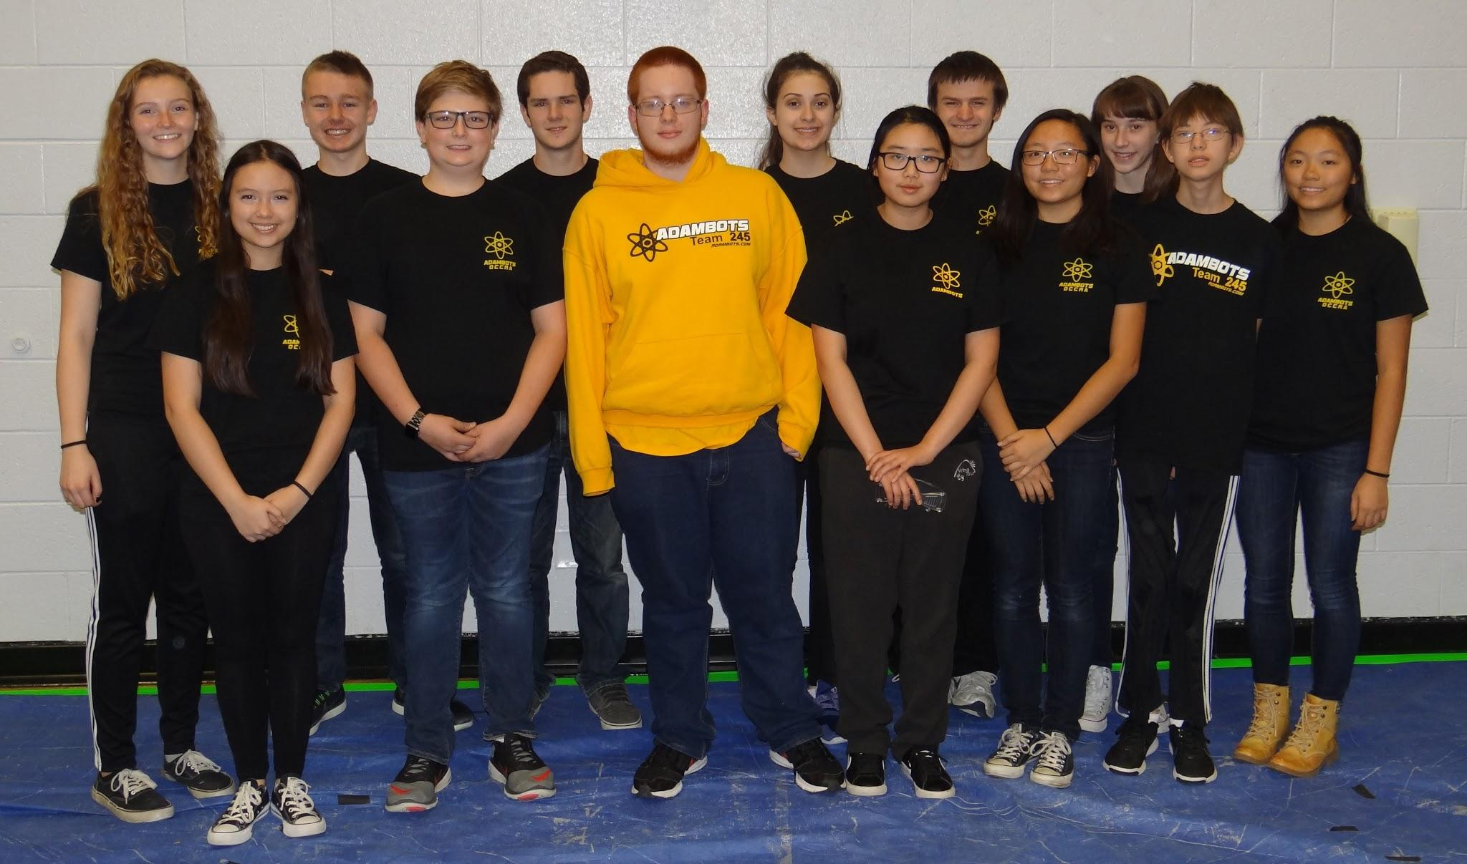

The AdamBots, team 245 from Rochester Adams High School, graciously submits our entry for the 2016 OCCRA Foundation Award. We believe we are a hardworking and exceptional team and request consideration for this prestigious award.

Team History with OCCRA:

The AdamBots have been competing in OCCRA since the league formed in 2000. At Rochester Adams High School, robotics is considered a club and therefore everything is done after school. Our school does not have a regular work facility, so we build our robot in the Computer Aided Design teacher’s work closet. Like other teams, we meet after school and occasionally on weekends to complete the design, CAD, build, and programming of our robot.

Previously, our OCCRA season was used as an introduction for our new students to robotics. However, our OCCRA team has evolved over the years. After using it as an introduction, the OCCRA team was split from our FIRST team and now only students who have at least one year of FIRST experience can participate. Experienced robotics students have the choice to be on both teams, FIRST and OCCRA, or just one. Since then, our FIRST and OCCRA teams have reunited and OCCRA is now treated as a special project for the upperclassmen. Many of our OCCRA students will use what they learned in OCCRA to be subteam leaders in the FIRST season. While the new students are not eligible for the OCCRA team, we do encourage them to take part in cheering at competitions and supporting our team as a whole.

Teamwork, Cooperation, and Enthusiasm:
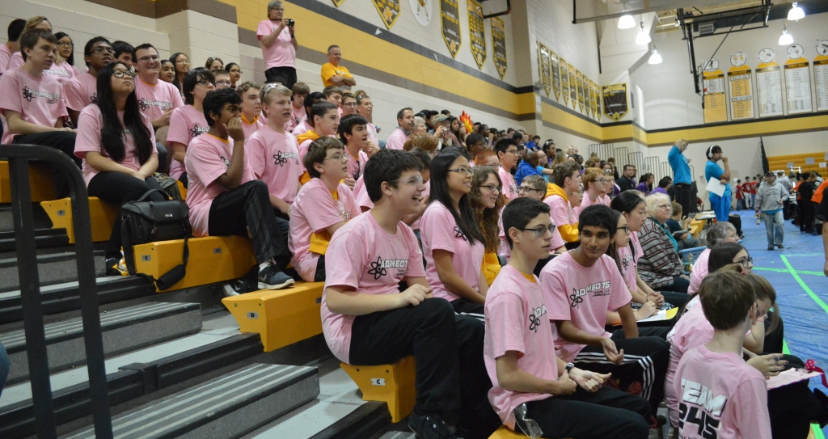
The AdamBots have consistently strived to be a spirited and supportive team. At every competition, the AdamBots are up and cheering on our team and competitors. Despite our team decreasing in size from 25 to 13 members this year, we always ensure a few students remain in the stands cheering. Despite our small size, we always stay for the entire competition in order to help out wherever we can. One of our team rules is that the team doesn’t leave until the trailer door closes. In 2013, 2014, and 2016, the AdamBots hosted OCCRA competitions at Rochester Adams High School and helped both the night before and the morning of to set up the field and stayed long after the competition to tear the field down.

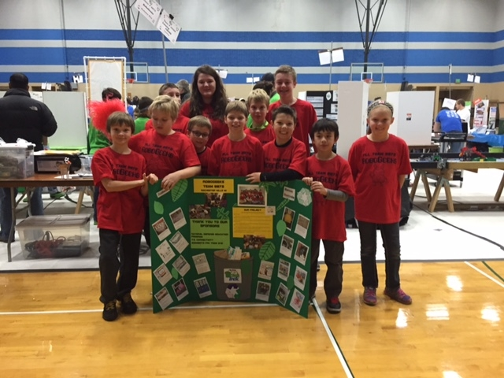
All team members on the AdamBots are required to volunteer for at least two service activities during the fall season. This year we participated in our own Hunger Walk for Rochester Area Neighborhood House and cleaned-up at the Halloween Hoot Event at Dinosaur Hill. We have also added six BASES (Before and After School Enrichment Services) classes to our list of fall service activities. In these classes, we teach STEM exploration to kids at local elementary schools. Throughout the year, the AdamBots also mentor several FLL teams at the local elementary schools. Our FLL and BASES classes impact over 80 kids. This December, the AdamBots will again be marching in the Rochester Holiday parade. We also participate as a team in the Relay for Life Cancer walk in the summer.

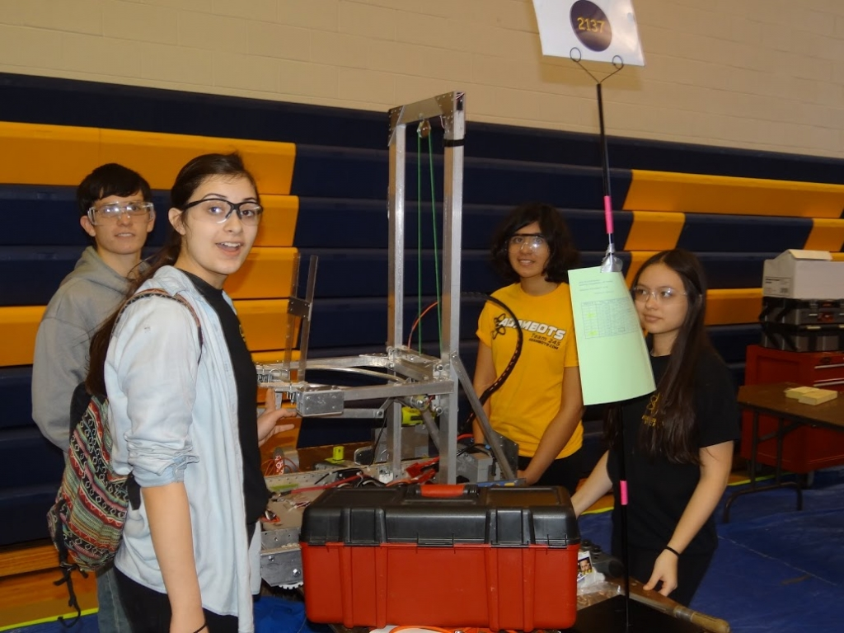
To raise the funds for the entry fee and to build our robots for OCCRA, we used some of the money from the Arts and Apples parking lot business we run in September. We are a self-funded team since we do not receive funds from our school system.

Every year at the OCCRA Diversity Tournament, we help out the teams that are lacking female members. We have a dedicated time for every girl on our team to practice driving so they are prepared to help out. This year, many of our girls were able to be on the field as a driver, human player, or coach for our team or another OCCRA team. This was a great experience for us and the enthusiasm of the girls could be felt throughout the competition.

Technical and Academic Disciplines and Problem Solving:
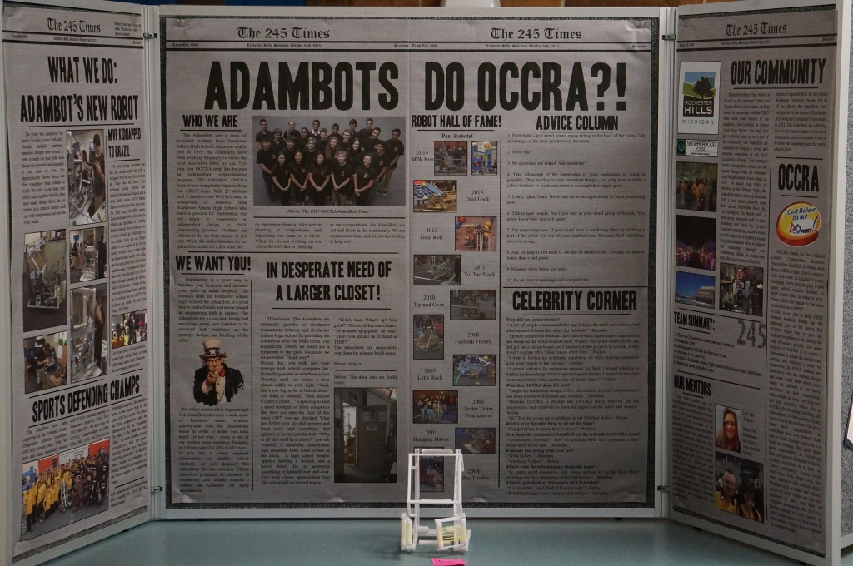
At the beginning of the OCCRA season, many of the team members attended the kick-off to learn about this year’s game. The team then quickly got to work on a strategy and design. In past years, OCCRA was split between the experienced students and the new students. The experienced students were assigned the task of building and programming the robot and the new students would go through an extensive training program where they work on other robots to learn how they function and how they are built. However, because our team now consists of only veteran students and is a lot smaller than before, a majority of the team spends time working on the robot and another small group works on the board and Foundation Award.

This year, the team has two mentors: Mr. Hildebrandt and Mrs. Alspach. They have been mentoring robotics teams for 19 and 3 years, respectively. While OCCRA is mainly student run, our mentors are active members of our team. They stay after school from 2:30 to 5:00 Monday through Thursday to ensure we are safe while building our robot as well as to provide guidance 1 hour a week. Furthermore, Mr. Hildebrandt and Mrs. Alspach manage our OCCRA team and guide us to have a fun and successful season. Mr. Hildebrandt’s engineering knowledge and Mrs. Alspach’s business experience are both invaluable resources to our team.
Safety First:

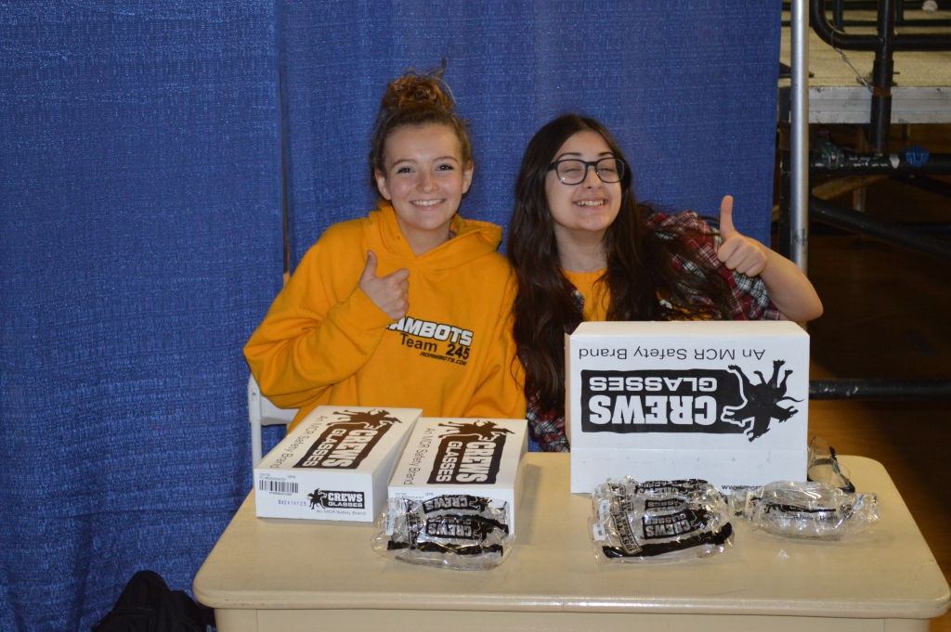
Safety is the AdamBot’s number one priority. To make sure safety is practiced, every student on our team has their own pair of safety glasses and is asked to bring them to all events. Extra pairs always remain available at the entrance to our build room for those who may have forgotten theirs or for parents who stop in to see our progress.

All sharp edges on the robot are filed down by students to reduce the chance of small cuts. Our vigilant mentor, Mr. Hildebrandt, is always there to make sure we are being safe.

OCCRA Successes for the AdamBots:
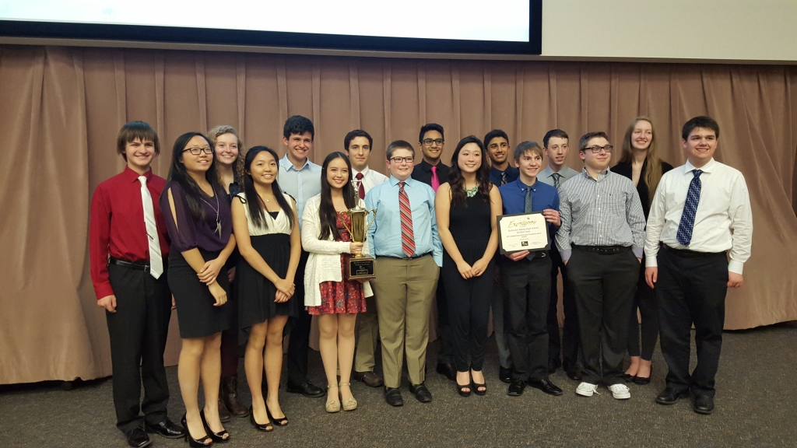
As a team, we have been extremely successful in OCCRA over the past fifteen years as evidenced by the many trophies proudly displayed at our school. We have won the OCCRA Championship five times and the Foundation Award five times as well. The AdamBots won the Foundation Award last year and are hoping for another win this year! We are looking forward to the Championships this year and can’t wait to see more teams hang!

Continuing the Journey:

The AdamBots participate in OCCRA because it is a great way to allow those students who are passionate about engineering to be able to experience it in an independent setting and get them excited about robotics before the FIRST season begins. We also continue to compete in OCCRA because we love it and could not imagine robotics without it. The ability to bring the robot back to school after a competition to make adjustments is fantastic and teaches us a lot about the real world engineering process.

The AdamBots will continue to make improvements every year. We will provide opportunities for our students to learn about science and technology through hands-on experiences and will work hard to create a strong foundation for future members.

We know that the process is working based on the number of alumni of the program who come back to visit us. OCCRA has made an impact on their lives and will continue to impact the lives of our current students.

Thank you for reading about our team and for considering us for the Foundation Award. If you would like to learn more, our website, www.adambots.com, has a full page on our OCCRA season as well as a photo gallery.

