2009 Oakland County Competitive Robotics Association
Rochester Adams High School – Team 245
Foundation Award Entry

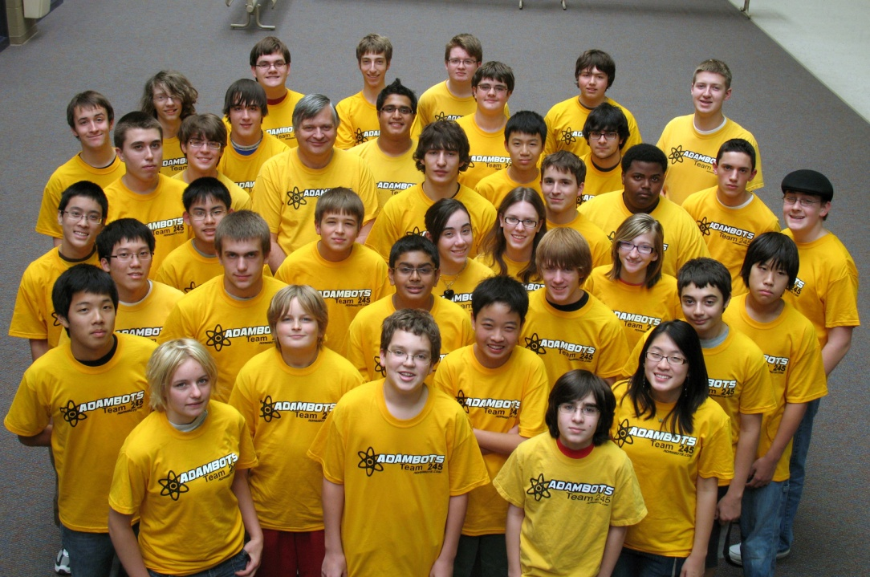
The Adambots, a combined team from Rochester Adams High School and Stoney Creek High School graciously submits our entry for the 2009 OCCRA Foundation Award. We believe we are an outstanding team and deserve your consideration for this prestigious award as explained below:

Team Information and History with OCCRA:

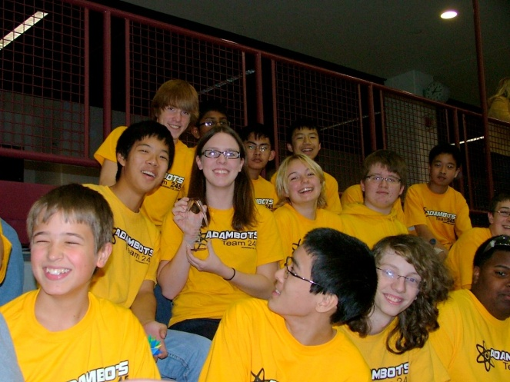
Team 245 has been successfully competing in OCCRA for many years. At Adams H.S., robotics is considered a “club activity” and therefore everything has to be done after school. Our school does not have any regular work facility so we build our robot in the Computer Aided Design room closet. Like other teams, our students meet after school and sometimes on weekends to complete the design, build and programming activities. For the 2009 OCCRA season we expanded our team by adding students from Stoney Creek High School. Stoney Creek does not have a robotics team so this is a chance for their students to be involved and learn how it all works. The Adambots thought this was a great way to spread the word and promote awareness of OCCRA in the school district.

In the past years, the Adambots have won the OCCRA County Championship several times and the Women’s Championship several times. The team is continuing the success this year already winning the Beautiful Bot award and the Quality award. Currently the team is in fourth place after two competitions.

The combined team has 44 students, many new to robotics this year.
Teamwork, Cooperation, and Enthusiasm:

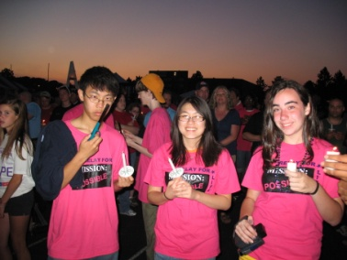
All you have to do is look into the stands and you can see the gold shirts of the Adambots. The team travels by school bus to competitions, each student contributing the money to pay for the cost of the bus, which gives all the students an opportunity to attend. The team also stays after each competition to help tear down the field and move the materials to the trailer. We not only cooperate with each other, we cooperate with OCCRA.

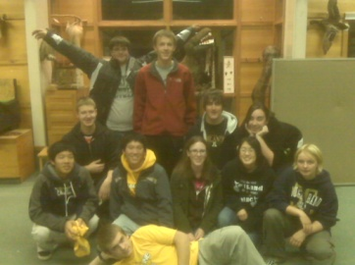
The team also supports local charity or service events by cooperating with several established organizations and showing up in the team shirts to provide support. For the past several years, we’ve had our own team for the Rochester Relay for Life event in June. For this event, we also bring a robot to demonstrate and allow relay participants to drive as a relay fundraiser.

We also help with the Dinosaur Hill Halloween Hoot helping clean up after the event. We also have members walk in the CROP walk in downtown Rochester.

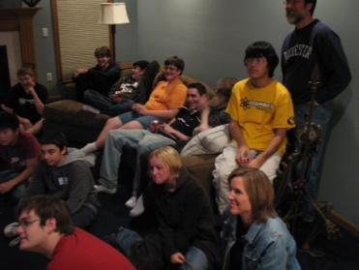
For OCCRA, we had a team pop can and bottle drive to raise the funds for the entry fee as all our OCCRA activities are self funded by the students on the team.

The team also held our own Road Rally to help build spirit and teamwork. The team then met afterward for food and got to enjoy the videos from the Rally.

For the OCCRA build season, we developed a schedule for each new student to have at least one day a week where they were assigned to work on the robot with an experienced student at Adams High School. This way, each student developed ownership in the robot and the team, because they each had a part in the entire process. The cooperation of all the students, from both schools, shows up in our large turnout for the events. Also this year, every new student that joined the team stayed active, which is the first time we did not have a student quit in the fall.

Technical and Academic Disciplines and Problem Solving:
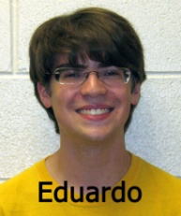
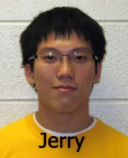
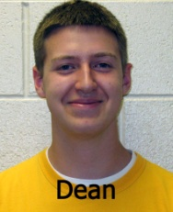
At the start of the OCCRA season, most of the team members attended the OCCRA kick-off to learn about this year’s game. Several also attended the technical sessions so they can share the learning(s) with the other team members. The team was then divided into workgroups so all could be involved. The VEX robot was primarily the responsibility of the Stoney Creek members, under the leadership of Eduardo, as well as the CAD drawing responsibility. The large robot was primarily built at the Adams closet, under the leadership of Dean and Jerry. Once a week the entire team gathers on Tuesday afternoon to compare notes, get instructions, and listen to the student captains so all know assignments and responsibilities. With a team this size it is challenging to give everyone an assignment. The student captains work together to solve the problems at the meetings and on the field.
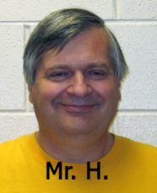
The team is also blessed with the guidance of Adams H.S. CAD Instructor, Mr. Warren Hildebrandt. He is fondly referred to as “Mr. H” by the students and lets the leaders make the decisions and run the meetings.

Safety First:

Every student has their own pair of safety glasses and is asked to bring them to all events. Extra pairs are available at the entrance to the closet for those who might not have theirs or for parents who want to stop in to see what’s going on.

All sharp edges on the robot are filed down by students to reduce the chance of small cuts. The more experienced students help those newer to tools and equipment so they do not accidentally hurt themselves.

Although the students are also encouraged to share many things with each other, we try not to share germs. Frequent hand washing is encouraged, especially before eating the food which is sometimes brought to our build session by generous parents.

Continuing the Journey:

The Adambots participate in OCCRA because it is a great way to involve the new team members and get them excited about robotics before the FIRST season begins. The ability to bring the robot back to school after a competition to make adjustments, mostly based on learning from other teams, is fantastic. It is a great way for the members to start their journey in the field of robotics, without the cost and pressure of the district, state, and worldwide FIRST events.

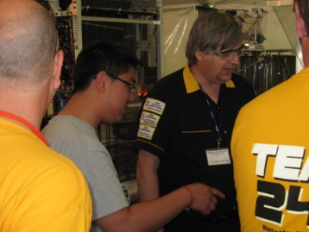
The Adambots will continue our journey to make improvements every year. We continue to be a year-round team with activities basically every month. We will continue to provide the opportunities for our students, and now the students of Stoney Creek, to learn about opportunities in science and technology, through hands-on experiences.

We know that the process is working based on the number of alumni of the program who come back to visit us. OCCRA has made an impact on their lives and will continue to impact the lives of our current students.

Thanks for reading about our team.

