2011 Oakland County Competitive Robotics Association
Rochester Adams High School – Team 245
Foundation Award Entry
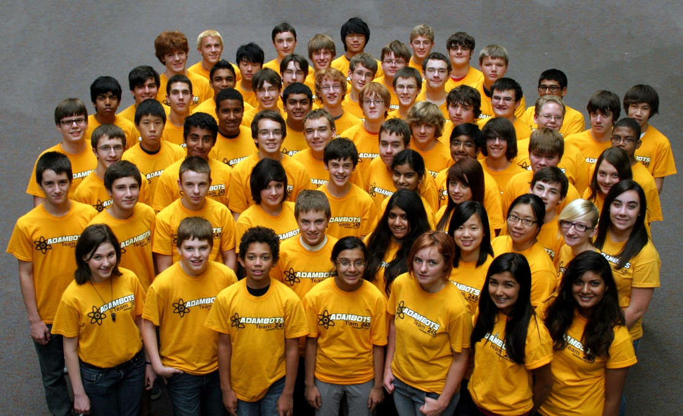
The Adambots, a combined team from Rochester Adams High School and Stoney Creek High School graciously submits our entry for the 2011 OCCRA Foundation Award. We believe we are an outstanding team and deserve your consideration for this prestigious award as explained below.

Team History with OCCRA:

Team 245 has been successfully competing in OCCRA since the league formed in 2000. At Adams High School, robotics is considered a club activity and therefore everything has to be done after school. Our school does not have any regular work facility so we build our large robot in the Computer Aided Design teacher’s work closet. Our VEX bot is built in the Computer Aided Design room. Like other teams, our students meet after school and sometimes on weekends to complete the design, build and programming activities. Stoney Creek did not have a robotics team until they joined our team three years ago so this is a chance for their students to be involved and learn how it all works. The Adambots thought this was a great way to spread the word and promote awareness of OCCRA in the school district.

Our OCCRA season has been used in the past years to introduce the incoming freshmen and new students to robotics. Throughout the OCCRA season they learn to work as a team and the ins and outs of how robotic competitions work. The Adambots have had many successful seasons with OCCRA including last year where we won the County Championship, along with Team 51, as well as the Foundation Award. The best part of OCCRA is being able to compete, learn from what went right or wrong and then working to make improvements week to week.

Teamwork, Cooperation, and Enthusiasm:

All you have to do is look into the stands and you can see the gold shirts of the Adambots. The team travels by school buses to competitions. Each student contributes money to pay for the buses, which gives all the students an opportunity to attend. The team also stays after each competition to help tear down the field and move the materials to the trailer. We choose this OCCRA chore each season because we have a large team and we can help get everyone home from the competitions a bit faster by pitching in to get the job done.

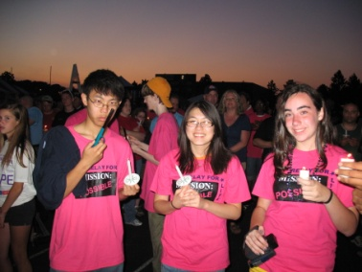
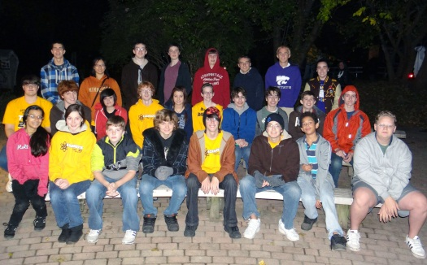
All team members from the Adambots are required to participate in at least one service activity during the OCCRA season. This year we participated in the Step Up for Down’s Syndrome, the Rochester area CROP Walk and also helped with the Dinosaur Hill Halloween Hoot, helping clean up after the event. We also participate as a team in the Relay for Life Cancer walk in the summer.

To raise the funds for the entry fee and to build our robots for OCCRA, we had a team pop can and bottle drive before school started this year. We are a self-funded team as we do not receive funds from the school system.

We also hold a Road Rally at the beginning of each OCCRA season to help build spirit and teamwork. The Road Rally ends with a big get- together for food and enjoying videos from the Rally. It’s a great team building activity!

As a special treat this year, the team went to the movie “Real Steel” because the robot’s name was Atom and our coach, Mr. Hildebrandt, was in the movie as an extra. This was another great entertaining team building experience.

Technical and Academic Disciplines and Problem Solving:
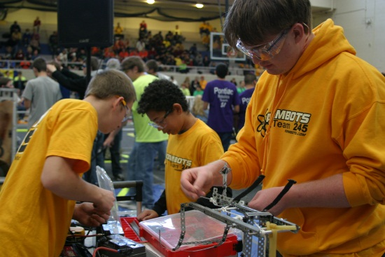
At the start of the OCCRA season, most of the team members attended the OCCRA kick-off to learn about this year’s game. Many also attended the technical sessions so they can share the learning with the other team members. The team was then divided into workgroups so all could be involved. Once a week the entire team gathers on Tuesday afternoon to compare notes, get instructions, and listen to the student captains so all know their assignments and responsibilities. With a team our size (68 students from two schools), it is challenging to give everyone an assignment. The student captains work together to solve the problems at the meetings and on the field.

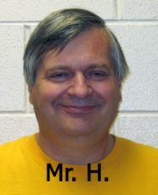
At the beginning of the build season, all new students are assigned individual work days. On their day, they are paired with an experienced student to help with the build. Since only ten students can be in the work room at a time, this gives all the new students a chance to get some hands on time with the robot.

The team is also blessed with the guidance of retired Adams H.S. CAD Instructor, Mr. Warren Hildebrandt. He is fondly referred to as “Mr. H” by the students and lets the leaders make the decisions and run the meetings.

Safety First:

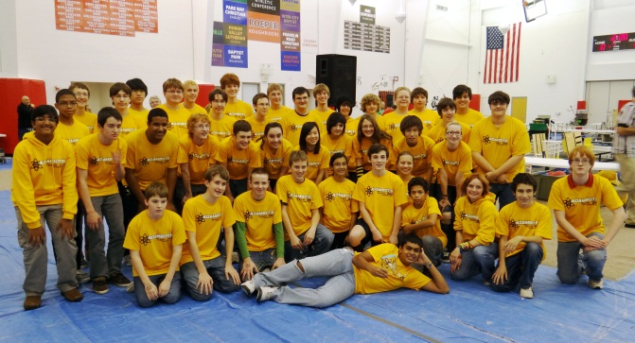
Every student has their own pair of safety glasses and is asked to bring them to all events. Extra pairs are available at the entrance to the build room for those who might not have theirs or for parents who want to stop in to see what’s going on.

All sharp edges on the robot are filed down by students to reduce the chance of small cuts. The more experienced students help those newer to tools and equipment so they do not accidentally hurt themselves.

Although the students are encouraged to share many things with each other, we try not to share germs. Frequent hand washing is encouraged, especially before eating the food which is sometimes brought to our build session by generous parents.

OCCRA Successes for the Adambots:
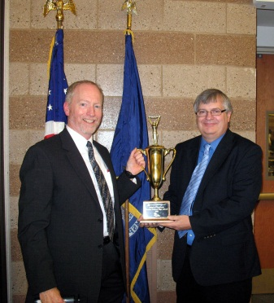
As a team, we have experienced much success in OCCRA in the past eleven years. We have shared the Championship title four times, came in second twice and our Women’s team won their Championship title three years in a row. We have been awarded the Spirit of the Competition Award 14 times over the past 11 years. Other awards also sit proudly in our school trophy case including 3 Quality Awards, 2 Technical Excellence Awards, 4 Judges Awards, two Strategic Design awards, a VEX and a Beautiful Bot Award. The crowning event though was winning the Foundation Award last year.

Continuing the Journey:

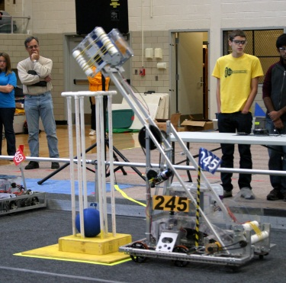
The Adambots participate in OCCRA because it is a great way to involve the new team members and get them excited about robotics before the FIRST season begins. The ability to bring the robot back to school after a competition to make adjustments, mostly based on learning from other teams, is fantastic. It is a great way for the members to start their journey in the field of robotics, without the cost and pressure of the district, state, and worldwide FIRST events.

The Adambots will continue our journey to make improvements every year. Our team grows each year, this year with 42 new students. We will continue to provide the opportunities for our students to learn about opportunities in science and technology, through hands-on experiences. We work hard on creating a strong foundation for these students and the ones that will join the team in the years to come.

We know that the process is working based on the number of alumni of the program who come back to visit us. OCCRA has made an impact on their lives and will continue to impact the lives of our current students.

Thanks for reading about our team.

